w/c 4th October

LO: To write an explanation text. The invention stage.

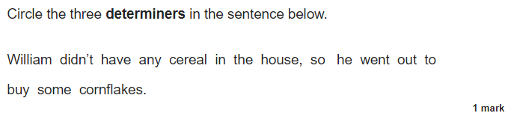

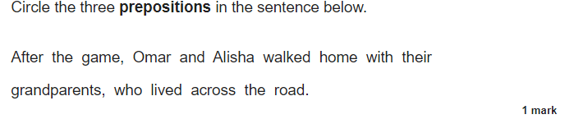

What my app icon looks like:

